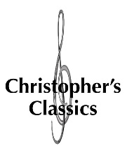
Christopher’s Classics Series XXII programme – 2017

Wilma & Friends
presented in association with Chamber Music New Zealand

The Piano, 156 Armagh St, Christchurch

7.30pm, Tues 26 September 2017

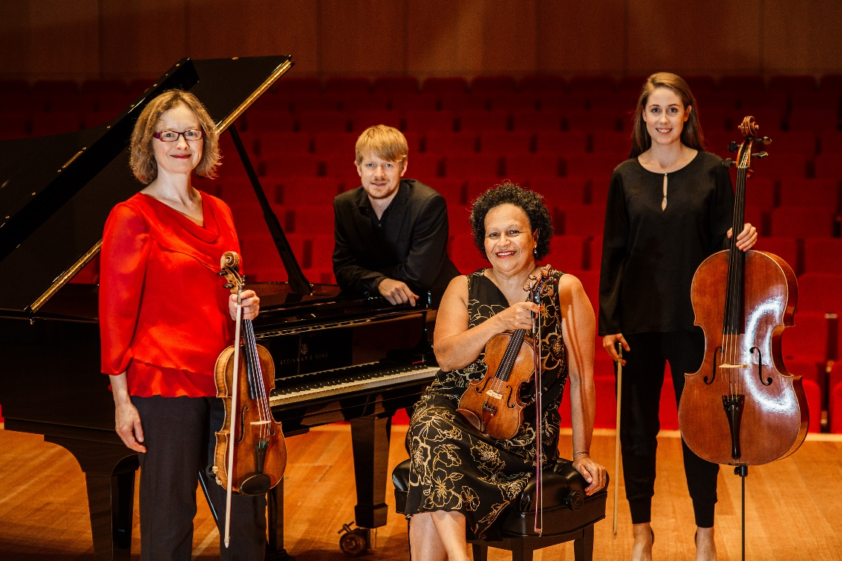
‘The busiest lives deserve beautiful music’
Walton – Piano Quartet in D Minor
Andrew Leathwick – Piano Quartet No. 1 (new commission)
Brahms – Piano Quartet No. 3 in C Minor, op. 60

Each year, celebrated Melbourne-based Kiwi violinist Wilma Smith invites performers of promise to form a group and create vibrant programmes that include everything from revered masterpieces to undiscovered gems of every musical era. This year she is joined by well-known viola player Caroline Henbest and two rising New Zealand-born stars of the Australian National Academy of Music (ANAM) in Melbourne – Alexandra Partridge on cello and Andrew Leathwick on piano.

The concert includes music by William Walton, written when the English composer was aged 16, the passionate, anguished love song by a young Brahms, extensively revised 20 years later with all its emotional power intact, and the premiere of a work by composer/pianist Andrew Leathwick, aged 24. Wilma commissioned Andrew to write the piece for this tour. “His compositional style is so original, accessible and appealing.”

Tickets $40; full-time students with ID, $15 Door sales: Cash & Eftpos Online tickets: Eventfinda - additional fees apply.
Media contact Diana Moir (03) 355 2691, 021 126 573 Christopher’s Classics Facebook www.christophersclassics.nz

About the artists
Wilma Smith, former Concertmaster of the Melbourne Symphony Orchestra and the NZSO, was born in Fiji and raised in Auckland. She studied in Boston at the New England Conservatory before becoming first violinist of the Lydian String Quartet, winners of the Naumburg Award for Chamber Music and multiple prizes at the Evian, Banff and Portsmouth International String Quartet Competitions. She also worked regularly with the Boston Symphony Orchestra and was Concertmaster for the Harvard Chamber Orchestra and Handel and Haydn Society. Invited to return home to form the New Zealand String Quartet, Wilma was first violinist of the group for five years before the NZSO appointed her Concertmaster. She has appeared as Guest Concertmaster with a number of orchestras and teaches violin at Melbourne and Monash Universities. She plays a 1761 Guadagnini violin.
Born in England, Caroline Henbest studied at the Yehudi Menuhin School and the Guildhall School of Music before joining the Mistry String Quartet, and then moving to Australia to take up the position of Principal Viola with the Australian Chamber Orchestra. She has performed as Guest Principal Viola with the Sydney Symphony, Melbourne Symphony, Hong Kong Philharmonic, City of London Sinfonia, Scottish Chamber Orchestra and Glyndebourne on Tour. She has worked extensively as a teacher – at Monash and Melbourne universities, the Australian National Academy of Music and the Sydney Conservatorium.
Born in Wellington, Alexandra Partridge holds a Masters of Musical Arts from the New Zealand School of Music and is currently studying at the Australian National Academy of Music in Melbourne. Alexandra’s piano trio, the Queensbridge Trio, was named a finalist at both the 2014 ANAM Chamber Music Competition and the Great Romantics competition held at the Melbourne Recital Centre. Alexandra has been selected as an Australian Chamber Orchestra Emerging Artist and toured with the Mahler Chamber Orchestra in Germany after successfully auditioning for their 2016 Academy Residency programme. She has been principal cellist of the NZSO National Youth Orchestra and is a casual player with the Melbourne Chamber Orchestra, New Zealand Symphony Orchestra, Orchestra Wellington and Southern Sinfonia. Alexandra has participated in masterclasses with the Borodin String Quartet and the London Haydn Quartet.

Andrew Leathwick is a pianist and composer studying piano at the Australian National Academy of Music in Melbourne. In 2010 he began studying piano with Katherine Austin at the University of Waikato, where he completed the requirements for a Master of Music with First Class Honours in 2014. While at the University of Waikato, Andrew was the winner of many awards and competitions, including the University of Waikato Cultural and Arts Person of the Year Award, the University of Waikato Concerto Competition, the University of Waikato Lilburn Trust Composition Awards, and the Sir Edmund Hillary Medal. In 2013, Andrew won the New Zealand National Concerto Competition with his performance of Prokofiev's Third Piano Concerto, also receiving the Junior Jury Prize and Audience Choice Award. While studying piano in Melbourne, he has performed with artists including Kathryn Stott and Anthony Marwood, and received the Ursula Hoff Institute Prize for outstanding performance in an ANAM recital.

Christopher’s Classics
The Christopher’s Classics programme, founded by Christopher Marshall, has become a mainstay of the Christchurch chamber music scene, showcasing some of New Zealand’s finest musicians. Following the 26 September concert, the 2017 series features rising youthful performers Tony Lin & Jun Bouterey-Ishido (2 November).

